## A

## Project Report

## on

# Placement Management System

# BTech-IT, Sem VI

Prepared By:

**Kathiriya Darshakkumar (IT057)**

**Limbani Nihal (IT064)**



##### Department of Information Technology

**Faculty of technology,**

**Dharmsinh Desai University**

**College road, Nadiad- 387001**

**April, 2021**

**A**

## Project Report

## on

# Placement Management System

## In partial fulfillment of requirements for

## System Design Practice

# BTech-IT, Sem VI

Submitted By:

**Kathiriya Darshakkumar (IT057)**

**Limbani Nihal (IT064)**

## Under the Guidance of

## Prof. (Dr.) Mukesh M. Goswami



##### Department of Information Technology

**Faculty of technology,**

**Dharmsinh Desai University**

**College road, Nadiad- 387001**

**April, 2021**

**CANDIDATE’S DECLARATION**

We declare that pre-final semester report entitled “**Placement Management System**” is our own work conducted under the supervision of the guide **Prof. (Dr.) Mukesh M. Goswami.**

We further declare that to the best of our knowledge the report for B.Tech. VI semester does not contain part of the work which has been submitted either in this or any other university without proper citation.

Candidate’s Signature

Candidate’s Name: **Kathiriya Darshakkumar**

Student ID: 18ITUOS097

Candidate’s Signature

Candidate’s Name: **Limbani Nihal**

Student ID: 18ITUOF051

**DHARMSINH DESAI UNIVERSITY**

**NADIAD-387001, GUJARAT**



**CERTIFICATE**

This is to certify that the project carried out in the subject of System Design Practice, entitled **“Placement Management System”** and recorded in this report is a bonafide report of work of

**1) Kathiriya Darshakkumar Roll No. IT057 ID No: 18ITUOS097**

**2) Limbani Nihal Roll No. IT064 ID No: 18ITUOF051**

of Department of Information Technology, semester VI. They were involved in Project work during academic year 2020-2021.

**Prof. (Dr.) Mukesh M. Goswami**

(Project Guide),

Department of Information Technology,

Faculty of Technology,

Dharmsinh Desai University, Nadiad

Date:

**Prof. (Dr.) V. K. Dabhi**

Head , Department of Information Technology,

Faculty of Technology,

Dharmsinh Desai University, Nadiad

Date:

## ACKNOWLEDGEMENT

It is indeed a great pleasure to express our thanks and gratitude to all those who helped us during this project. This project has given us a great opportunity to think, implement and interact with various aspects of the Software Development Life Cycle. We would like to acknowledge all the people who have helped us at one stage or another by providing the much-needed support, encouragement and groundwork to complete our project.

We express a deep sense of gratitude towards our project guide **Prof. (Dr.) Mukesh M. Goswami** towards his innovative ideas and earnest effort to make our project a success. It is his sincerity that prompted us throughout the project to do hard work using the industry adopted technologies. Our commitment to the application is the sole result of patience, hard work and dedication being inspired by him.

A blend of gratitude, pleasure and great satisfaction is what we feel to convey our indebtedness to all those who all have directly or indirectly contributed towards completion of the project.

With Sincere Regards,

**Kathiriya Darshakkumar**

**Limbani Nihal**

**TABLE OF CONTENTS**

ACKNOWLEDGMENT iii

ABSTRACT vi

LIST OF FIGURES vii

LIST OF TABLES viii

1. Introduction 1
   1. Project Details: 1
   2. Purpose 1
   3. Scope 1
   4. Objective 2
   5. Technology and Literature Review 2
2. Project Management 3
   1. Feasibility Study 3
      1. Technical feasibility 3
      2. Time Schedule feasibility 3
      3. Operational feasibility 3
      4. Implementation feasibility 4
   2. Project Planning 4
      1. Project Development Approach and Justification 4
      2. Project Plan 6
      3. Roles and Responsibilities 6
3. System Requirements Study 7
   1. Problems and Weaknesses of Current System 7
   2. User Characteristics 7
   3. Hardware and Software Requirements 8
   4. Constraints 9
      1. Hardware Limitations 9
      2. Interfaces to Other Applications 9
      3. Reliability Requirements 9
   5. Assumptions and Dependencies 9
4. System Analysis 10
   1. Requirements of New System 10
      1. User Requirements 10
      2. System Requirements 11

4.2 ER-Diagram 15

4.3 Data Dictionary 16

1. System Design 19
   1. Use Case Diagram 19
   2. Class Diagram 21
   3. Sequence Diagram 22
   4. Component Diagram 24
   5. Deployment Diagram 25
2. Implementation Planning 26
   1. Implementation Environment 26
   2. Program/Modules Specification 26

6.3 Coding Standards 27

1. Testing 28
   1. Testing Plan 28
   2. Testing Strategy 28
   3. Testing Methods 28
   4. Test Cases 29
2. User Manual 31
   1. Digital User Manual 31
3. Limitation and Future Enhancement 41
4. Conclusion and Discussion 42
   1. Conclusions and Future Enhancement 42
   2. Discussion 42
      1. Self Analysis of Project Viabilities 42

10.2.3 Problem Encountered and Possible Solutions 42

10.3.3 Summary of Project work 42

1. References 43

**ABSTRACT**

Placement Management System is created with aim to provide efficient platform for Placement related all the features. It provides facilities to all persons related to placement process, College TPO to manage Oncampus Job and Company (HR) to manage Offcampus and Oncampus Job and Student to apply both Job.

There are currently some systems which more or less implement the features that we’ll be providing, but not all the features that we provide are covered in a single application.

**LIST OF FIGURES**

|  |  |  |
| --- | --- | --- |
|  | **Name** | **Page No.** |
| Fig 2.2.1 | Agile Model | 5 |
| Fig 4.2 | Er-Diagram | 15 |
| Fig 5.1(a) | TPO Use Case Diagram | 19 |
| Fig 5.1(b) | Student and Company Use Case Diagram | 20 |
| Fig 5.2 | Class Diagram | 21 |
| Fig 5.3(a) | Seq. Diagram User (Login Register Logout) | 22 |
| Fig 5.3(b) | Seq. Diagram User (View/Edit/Change password) | 22 |
| Fig 5.3(c) | Seq. Diagram COMPANY (HR) | 23 |
| Fig 5.3(d) | Seq. Diagram TPO | 23 |
| Fig 5.3(e) | Seq. Diagram Student | 24 |
| Fig 5.4 | Component Diagram | 24 |
| Fig 5.5 | Deployment Diagram | 25 |

**LIST OF TABLES**

|  |  |  |
| --- | --- | --- |
|  | **Name** | **Page No.** |
| Table 2.2.2 | Project Plan | 6 |
| Table 2.2.3 | Roles and Responsibilities | 6 |
| Tables 4.3 | Data Dictionary | 16 |
| Table 7.4 | Test Cases | 29 |

1. **INTRODUCTION**
   1. **Project Details: Broad specifications of the work entrusted to you.**

Title: Placement management system

Features:

* Our system aims at providing the compatibility to simplify the process of placement for students, Companies and TPO.
* This system that consists of a student login, company login and a TPO login. This is beneficial for college students, various companies visiting the campus for recruitment and even the college placement officer.
* The system consists of a company login where various companies can view a list of students in that college and also their respective Academic details and assign offcampus Job announcement and also request TPO for job announcement. Also see the applied student list.
* TPO can add student details, view student details and announce Oncampus job to student. And TPO can see the company details and requested company’s job request.
* The software system allows the students to create their profiles or TPO added student login. Students can view a list of companies. See oncampus/offcampus job details and applied on it.

* 1. **Purpose**

The purpose of the project is to build a web-application program to reduce the manual work for placement cell of all colleges, for students and for companies. It maintains records of students and as well as companies instead of written materials. The project focuses on designing a System for graduating students to a pool companies from various domains.

* 1. **Scope**

Our project has a big scope to do. We can store information of all the students, Companies, TPO. Various companies can access the information. Company announced jobs. Students can maintain their information and can update it. Student can view and apply the Oncampus/Offcampus job. All Information can manage by collage respective officers(TPO). And there are many more scope…

* 1. **Objective (Scope – what it can do and can’t do)**
* The main objective of the project on “Placement Management System” is to manage the details of students, company, Training and placement officer.
* Placement activities becomes more interactive, automated and effective.
* User friendly interface.
* Save time & work load for placement cell.
* To increase the accuracy and efficiency of placement procedure.
* Management of Student Data as well Company Data.
* Analysis of overall Placement.
  1. **Technology and Literature Review**

Following technologies will be used for development/management/tracking activities….

1) Nodejs, Express JS For Server-Side Programming

2) Bootstrap, JavaScript, jQuery (Basic HTML, CSS) For Client-Side Programming, Designing

3) MySQL Database System for Data Storage and Management

1. **PROJECT MANAGEMENT**

* 1. **Feasibility Study**
     1. **Technical feasibility**

Viewing our project from technical point of view (thinking about various tools and technologies being used in developing the system). We have decided that following technologies will be more than enough to develop complete working system (including tech. & tools used for project tracking, monitoring etc. along with development).

·        For Front End: Bootstrap, JavaScript, jQuery (Basic HTML, CSS)

·        For Back End: Nodejs, Express JS

·        Database: MySQL

We are equipped with basic workflows of each tools and tech. and capable to explore further if required. Each of the above technologies is freely available and some of the skills yet to be learnt but it is manageable. From this, it is clear that our project is technically feasible.

2.1.2 **Time schedule feasibility**

We have planned the steps for completion of our project in given duration. Firstly, We will requirement gathering & analysis by 9th January 2021. We will prepare SRS document and the GUI design tentatively by 16th January 2021.The diagrams required for the design as well as the database design will be tentatively completed by 30 January 2021.For coding and unit testing 4 weeks and for system and integration testing another 2 weeks will be required. Hence tentatively by the end of February 2021. We will be able to complete the project and ready for its demonstration at starting of March 2021. Being a 2members team we will be able to complete our project in the estimated time.

2.1.3 **Operational feasibility**

In current COVID pandemic situation and work from home, we are forced to manage our project remotely. So, operability and management of project is going to be somewhat difficult but it will be quite feasible to develop project remotely as well as good social media platforms to communicate ideas and work regarding the project. Also, we are team of 2 persons. So from organizational point of view, it is sufficient to maintain proper teamwork even remotely. Hence our project is operationally feasible.

2.1.4 **Implementation feasibility**

We will be working full WEB application for first time. So we need to learn the basic of Nodejs as well as the use of JavaScript libraries to create graphics and animation needs to be learned. And we are little aware of MySQL.

Since, we are well aware with basics of JavaScript, HTML, CSS and as Bootstraps easy to understand our learning will take around 2 or 3 weeks and be completed before starting implementation.

* 1. **Project Planning**

* + 1. **Project Development Approach and  Justification**

We would be using the Agile model for project development. Agile methods break tasks into smaller iterations, or parts do not directly involve long term planning. The project scope and requirements are laid down at the beginning of the development process. Plans regarding the number of iterations, the duration and the scope of each iteration are clearly defined in advance.

Following are the phases in the Agile model are as follows:

1. Requirements gathering

2. Design the requirements

3. Construction/ iteration

4. Testing/ Quality assurance

5. Deployment

6. Feedback

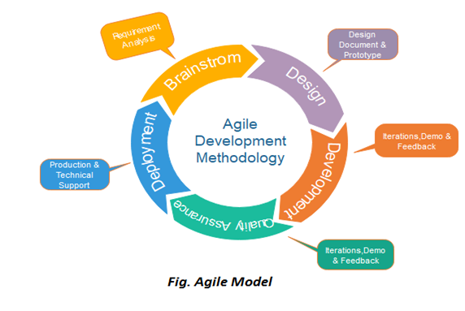

*Fig 2.2.1 Agile Model*

Advantages of Agile model:

* Customer satisfaction by rapid, continuous delivery of useful software.
* People and interactions are emphasized rather than process and tools. Customers, developers and testers constantly interact with each other.
* Working software is delivered frequently (weeks rather than months).
* Face-to-face conversation is the best form of communication.
* Close, daily cooperation between business people and developers.
* Continuous attention to technical excellence and good design.
* Regular adaptation to changing circumstances.
* Even late changes in requirements are welcomed.

Disadvantages of Agile model:

* In case of some software deliverables, especially the large ones, it is difficult to assess the effort required at the beginning of the software development life cycle.
* There is a lack of emphasis on necessary designing and documentation.
* The project can easily get taken off track if the customer representative is not clear what final outcome that they want.
* Only senior programmers are capable of taking the kind of decisions required during the development process. Hence it has no place for newbie programmers, unless combined with experienced resources
  + 1. **Project Plan**

|  |  |  |  |  |  |  |  |  |  |  |  |  |  |  |  |  |  |  |
| --- | --- | --- | --- | --- | --- | --- | --- | --- | --- | --- | --- | --- | --- | --- | --- | --- | --- | --- |
| **Task Name** | **Start** | **Finish** | **December** | | | | **January** | | | | **February** | | | | **March** | | | |
|  |  |  | **1** | **2** | **3** | **4** | **1** | **2** | **3** | **4** | **1** | **2** | **3** | **4** | **1** | **2** | **3** | **4** |
| **Plan and Feasibility Study** | 25/12/2020 | 09/01/2021 | | | | | | | | | | |  | | | |  | | | |
| **Requirements gathering** | 10/01/2021 | 16/01/2021 |  | | | | | | | | |  | | | |  | | | |
| **Analysis** | 17/01/2021 | 23/01/2021 |  | | | | | | | | |  | | | |  | | | |
| **Design** | 24/02/2021 | 30/01/2021 |  | | | | | | | | |  | | | |  | | | |
| **Coding** | 31/01/2021 | 27/02/2021 |  | | | |  | | | | | | | | | | | |  | | | |
| **Testing** | 28/02/2021 | 06/03/2021 |  | | | |  | | | |  | | | | | | | | | |

*Table 2.2.2*

* + 1. **Roles and Responsibilities**

Front-end: Nihal & Darshak

Back-end: Darshak

Database: Darshak & Nihal

|  |  |  |  |  |  |  |
| --- | --- | --- | --- | --- | --- | --- |
| Name | Analysis | Design | Coding | Testing | Documentation | Maintenance |
| Darshak  Kathiriya | ✔ | ✔ | ✔ | ✔ | ✔ |  |
| Nihal  Limbani | ✔ | ✔ | ✔ | ✔ |  | ✔ |

*Table 2.2.3*

1. **SYSTEM REQUIREMENTS STUDY**
   1. **Problems and Weaknesses of Current System**

The following Problems exist in current system,

* Maximum manual work: in the existing system all the work that is done by human intervention.
* Humans should do all the work.
* Errors: due to the manual intervention there are maximum chances of errors.
* Maximum human interface: the interface between the student and administrator is maximum;
* Time consuming: due to above problems every procedure becomes time consuming.
* File system: the records were stored in modified access sheets hence sorting problem.
* No hierarchical: the files were not stored hierarchical format hence searching problems.
* Updating records: due to above problems the updating was very difficult and ambiguous
* Duplication of files: due to above problems the duplication of records was usual hence data
* Redundancy.
* Less alertness: the students may not get the information on internship and placement activity hence they miss the opportunities.
  1. **User Characteristics (Type of users who is dealing with the system)**

There are three type of user in system require:

1) TPO

2) Student

3) Company (HR)

1.TPO

* TPO needs to sign up register giving complete details or login and later view and update details.
* It can manage student add/view details and do Oncampus job announce.
* It can see request of company(hr) regarding to job and assign job to student and see applied student list.

2. Student

* Student need to sign up register giving complete details or login and later view and update details.
* They can view and apply for any Company announce job Offcampus or on campus job announcement.

3. Company (HR)

* The Company initially has to sign up register giving complete details or login and later view and update details.
* The Company(hr) has to request the Placement officer for Oncampus job announcement.
* It also assign Offcampus job announcement.
* The Company may shortlist the students who applied. They may use their details (academic as well as personal).
  1. **Hardware and Software Requirements (minimum requirements to run your system)**

There are no such specific hardware requirements other than basic requirements such as a computer with good internet connectivity and a decent browser.

Software: -

* Operating System: Windows Operating System 2000 and Above and Linux
* Web Browser: Mozilla firefox, Edge, Chrome, Safari
* Language Nodejs, JavaScript (Bootstrap 4, jQuery)
* Mysql database tools
* Vs Code or any Other IDE

MY SQL Tools : It is a relational database management system. As a database it‘s a software product whose primary function is to store & retrieve data as requested by other software applications, be it those on the same computer or those running on another computer across a network (including the internet).

Vs-Code: For IDE use. as It well suitable for JavaScript and basic html and CSS. also Use for backend.

You can use any Ide or editor which support JavaScript related lang. for writing

* 1. **Constraints**
     1. Hardware Limitations
  + There is only one limitation of this application, that is it will work only web based system.
    1. Interface to other applications
  + There are no other systems that use this application as an interface.
    1. Reliability Requirements
  + The application does demand much reliability and it is fully assured that the particular information about the users should be secured and flow is maintained and accessed according to the rights.
  1. **Assumptions and Dependencies**

1. User has sufficient privileges to access the internet.
2. Server is running smoothly.
3. Database updates are giving expected and accurate results.
4. We assume that student and company details are consistence.
5. **SYSTEM ANALYSIS**
   1. **Requirements of New System (SRS)**
      1. **User Requirement**
6. TPO
7. Student
8. Company (HR)
9. TPO

* View details: Allows TPO to view his and college details.
* Update details: Allows TPO to Update all details.
* Change password: This service enables TPO to change password.
* Add student: Allows TPO to add a student to database with excel file.
* View Student details: Allows TPO view and search for student information.
* View Company details: Allows TPO view and search for company information.
* Request Section: Allows TPO view company job request and assign jobs to students.
* Oncampus Job Announce: Allows TPO to see All Oncampus job and Remove assign Job and also see applied students list.

1. Student:

* View details: Allows Student to view his details.
* Update details: Allows Student to Update all details.
* Change password: This service enables Student to change password.
* View Company details: Allows Student view and search for company information.
* View Offcampus Job: Allows Student to see all job details which announce by company direct and also apply for this job.
* View applied Offcampusjob list.
* View TPO details: Allows Student view their TPO information if student is verified.
* View Oncampus Job: Allows Student to see all oncampus job/intern details announce by company and assign by tpo direct and also apply for this job.
* View applied Oncampusjob list.

1. Company (HR):

* View details: Allows Company (HR) to view his details.
* Update details: Allows Company HR to Update all details.
* Change password: This service enables Company Hr to change password.
* View Student details: Allows HR view and search for all students information.
* Job Announce: Allows Company HR to announce offcampus job to whole system students.
* List of Offcampus Job: Allows Company HR to see update and delete job announce. And also see student list who applied.
* View TPO details: Allows HR view and search for all tpo and college information.
* Request Tpo: Allows Company HR to request tpo for Job Announce.
* View Request: Allows Company HR to see update and delete job Request.
* View Accepted request: Allows Company HR to see all tpo accepted job Request. And also see student list who applied.
  + 1. **System Requirements**

1. **Functional Requirements**

**R.1Login:**

R1.1 Verify login and password

Input: TPO, Student, Company (HR) provides Email and password.

Output: System allows to proceed or error message.

Process: System verifies Email and password to database.

R1.2: New Registration

Input: TPO, Student, Company (HR) will enter some general information.

Output: User will get conformation or error message.

Process: System will add new entry to database.

**R2.1 View Details:**

Input: User Select or click to this Module.

Output: System allows to see all details.

**R2.2 Edit Details:**

Input: User Select or Click to Edit Module and enter details.

Output: System allows to user to update their details.

Process: System will update data into database.

**R2.3 Change Password:**

Input: User Select and enter proper password related details.

Output: System allows to change password or show error if exits.

Process: System will update password into database.

**R2.4 TPO:**

R2.4.1: Add Student

Input: User Select this module and add excel sheet.

Output: System display message after add successful.

Process: System will all student data to database with proper format.

R2.4.2: View Student

Input: User Select this module

Output: System display the student list of their college

R2.4.3: Oncampus Job Announce

Input: User Select this module

Output: System show list of job which assign to student

* User can edit dates
* See applied student list

R2.4.4: View Company

Input: User Select this Module

Output: System show list of company which available in database.

R2.4.5: View Request

Input: User Select this module and also assign job to student

Output: System show the list of job request

Process: If job assign to student then change database data

**R2.5 Company (HR):**

R2.5.1: View Student

Input: User Select this Module

Output: System show list of Students details available in system

R2.5.2: Offcampus Job Announce

Input: User select this module and enter all details about job

Output: System show the message job assign successful or not

Process: data stores to database jobdetails table.

R2.5.3: View Job Assign

Input: User Select this Module

Output: System show all offcampus job assign records.

* User can edit Job and delete Job.
* See applied student list.

R2.5.4: View TPO

Input: User Select this Module

Output: System Show all tpo and college details which available in database

R2.5.5: Request TPO Job

Input: User enter all details about job request

Output: system display the message about job request successful

Process: data stores to database jobdetails table with proper inputs.

R2.5.6: View Request

Input: User Select this Module.

Output: System show list of request list of job.

R2.5.7: View Accepted Job

Input: User Select this Module.

Output: System show list of accepted job by tpo.

* User can edit Job and delete Job.
* See applied student list.

**R2.6 Student:**

R2.6.1: View Company

Input: User Select this Module.

Output: System show list of company details.

R2.6.2: View Offcampus Joblist

Input: User Select this Module

Output: System show list of offcampuse job list

Process: System first check in jobdetails datatable and then display

Proper job

* User can apply for job
* View applied job

R2.6.3: View TPO

Input: User Select this Module

Output: System show tpo details if student is verified.

R2.6.4: View OnCampus Joblist

Input: User Select this Module

Output: System show oncampus Job lists if student is verified.

Process: System first check in jobdetails datatable and then display

Proper job

* User can apply for job
* View applied job

1. **Non-Functional Requirements**
2. Security

Security is primary requirement of any system. This platform must maintain/process data in secure way so unauthorized entities do not have illegal access of it.

1. Performance

Performance requirements define how well the system performs certain functions under specific conditions. Examples are speed of response, throughput, execution time and storage capacity. ... Like most quality attributes, performance requirements are key elements when designing and testing the product. This platform should be designed in such a way that its performance is smooth for users.

1. Scalability

Scalability is a property of a system that describes the ability to appropriately handle increasing (and decreasing) workloads. Scalability competes with and complements other non-functional requirements such as availability, reliability and performance. This platform must be designed in such way that it is able to scale well with increasing/decreasing accesses, users etc.

1. Availability

System must be available to authorized users when it required. This platform must be designed in such a way that it is always available to authorized user and should handle abnormal scenarios well by displaying proper message to users. In any abnormal situations, users data should not be lost.

* 1. **ER Diagram**

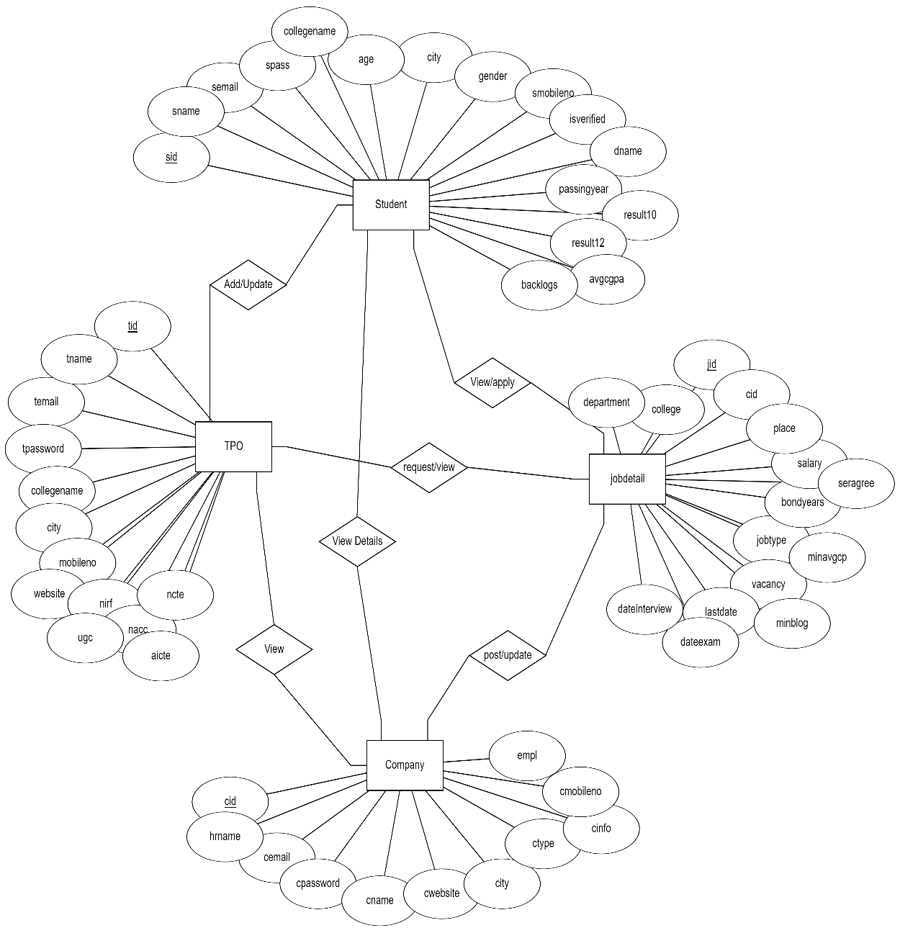

*Fig 4.2 ER diagram*

* 1. **Data Dictionary**

**TPO**

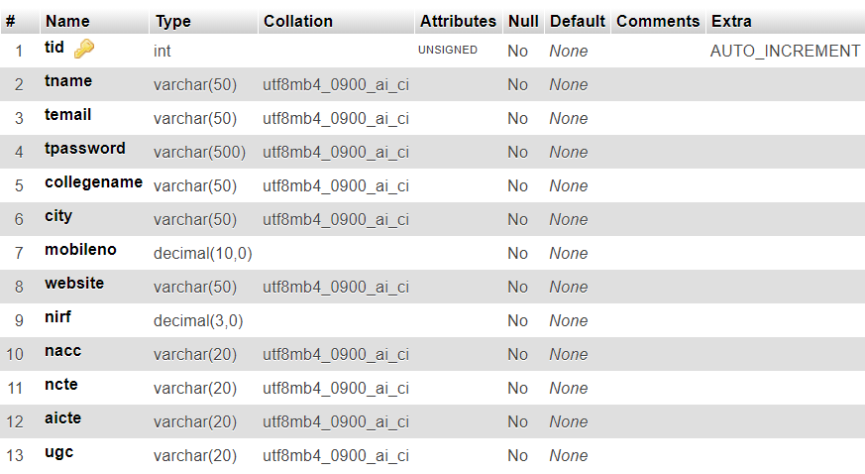

**Company**

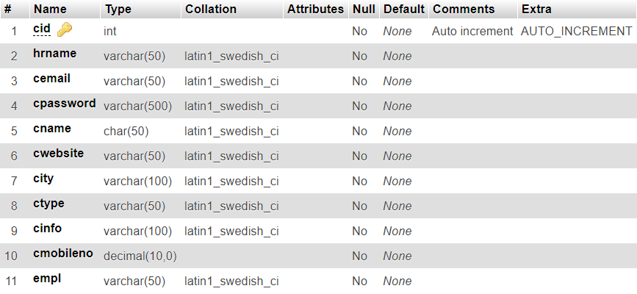

**Student**

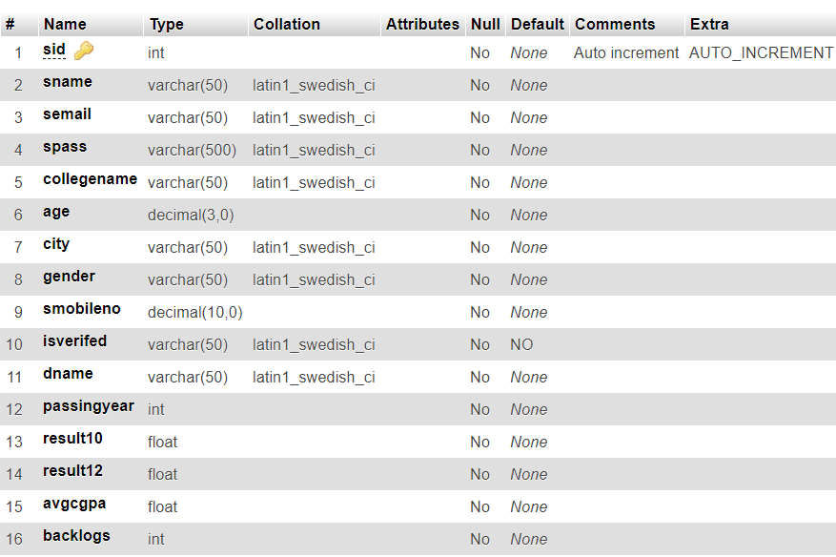

**Jobdetail**

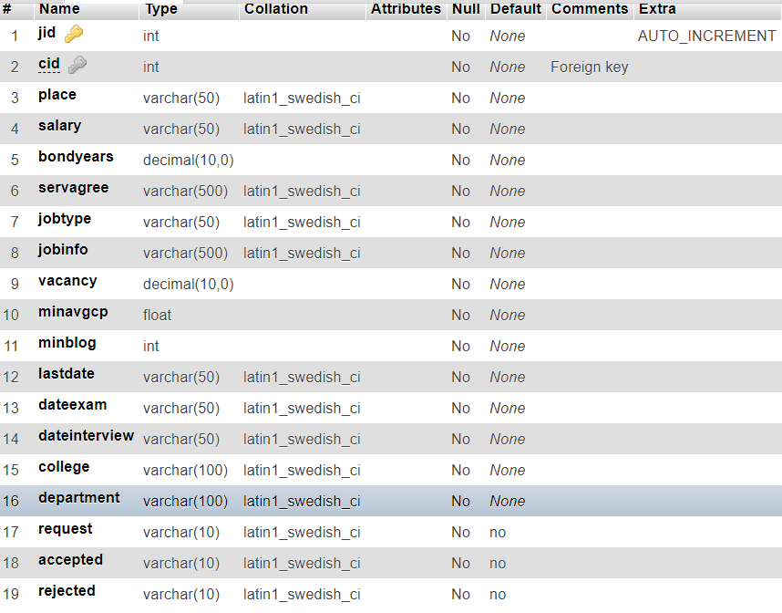

**Applied**

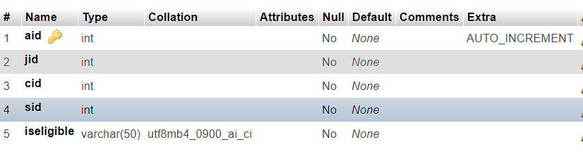

1. **SYSTEM DESIGN**
   1. **Use Case Diagram**

* TPO

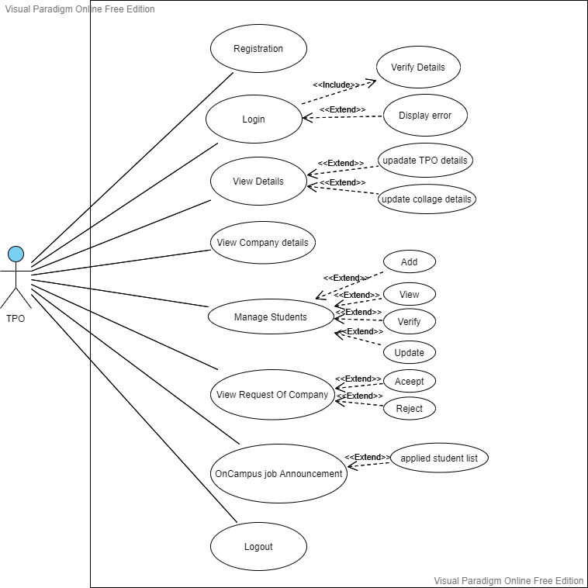

*Fig 5.1(a) TPO Use Case Diagram*

* Student & Company(HR)

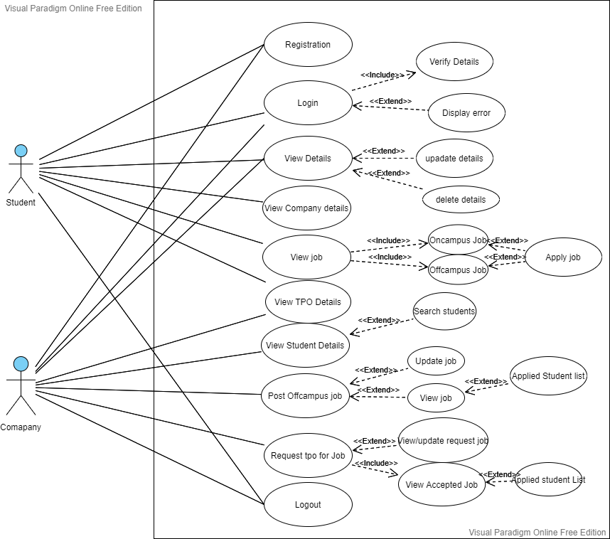

*Fig 5.1(b) Student and Company Use Case Diagram*

* 1. **Class Diagram**

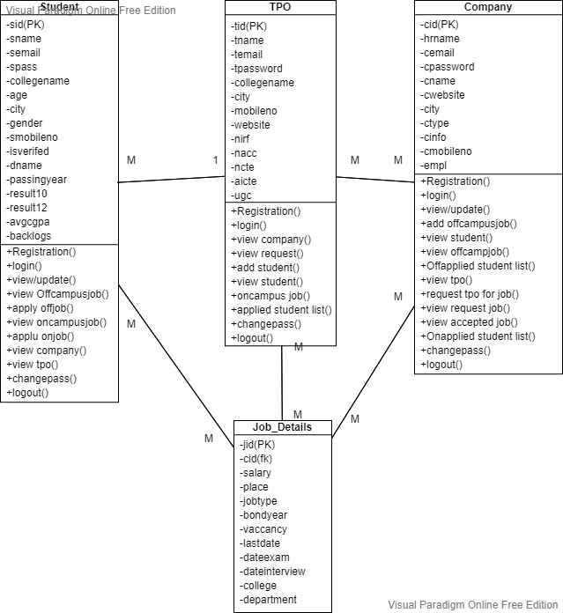

*Fig 5.2 Class Diagram*

* 1. **Sequence Diagram**

**User (Login Register Logout)**

**(Common TPO/Student/Company(HR) Module)**

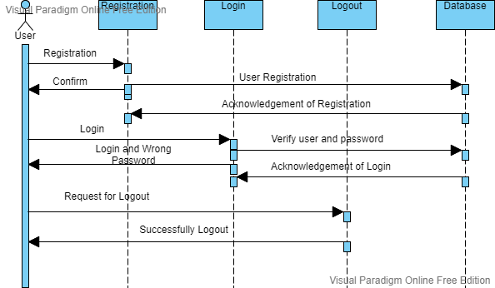

*Fig 5.3(a) User (Login Register Logout)*

**User (View/Edit/Change password)**

**(common TPO/Student/Company(HR) Module)**

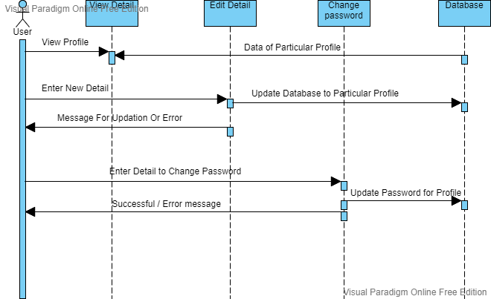

*Fig 5.3(b)* *User (View/Edit/Change password)*

**COMPANY (HR)**

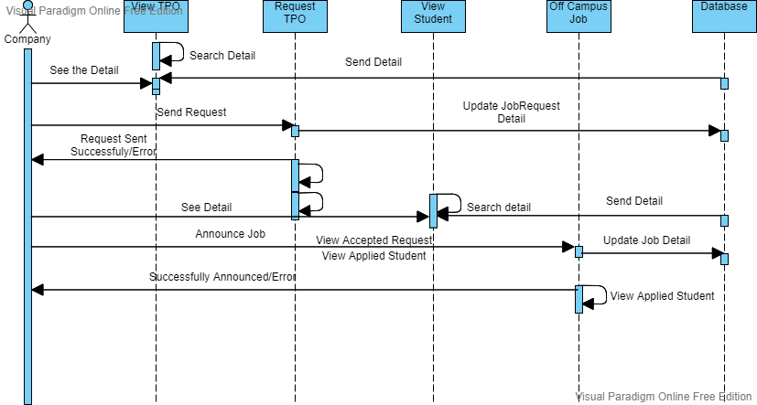

*Fig 5.3(c)* *COMPANY (HR)*

**TPO**

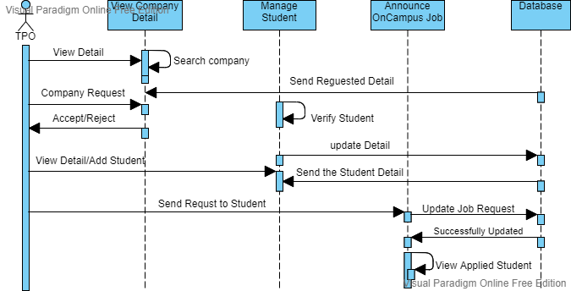

*Fig 5.3(d)* *TPO*

**STUDENT**

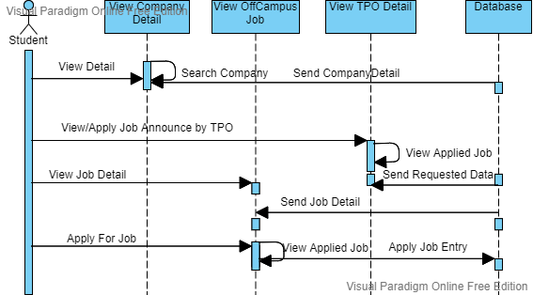

*Fig 5.3(e)**Student*

* 1. **Component Diagram**

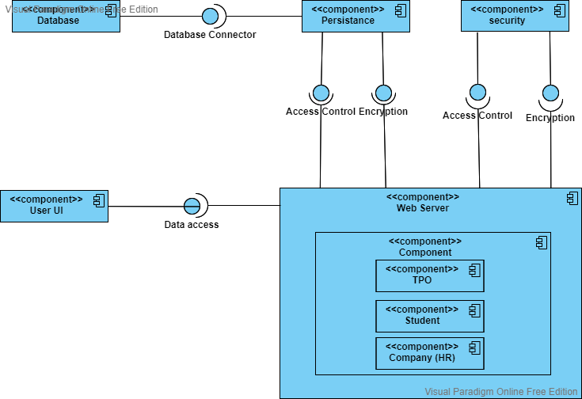

*Fig 5.4* *Component Diagram*

* 1. **Deployment Diagram**

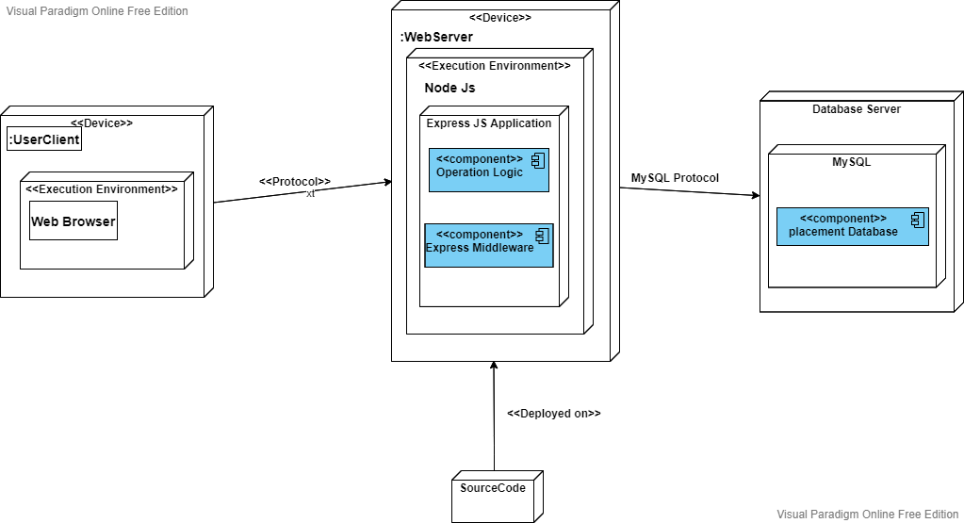

*Fig 5.5* *Deployment Diagram*

1. **IMPLEMENTATION PLANNING**
   1. **Implementation Environment (Single vs Multiuser, GUI vs Non GUI)**

For implementation we have used:

1. Visual Studio Code

2. Wamp Server

### 

Our project is build using Node Js for the backend purposes and Bootstrap, JavaScript, jQuery Basic Html/CSS for the frontend purposes. And for the database purpose we have used MySql.

**Learn GUI Designing using Figma Tool:**

<https://www.figma.com/file/6AsHxbyJsVLEh0SoFROrWa/Placement?node-id=0%3A1>

* 1. **Program/Modules Specification**

The following Modules are implemented:

* TPO
* View / Edit Profile
* Change Password
* View Company Details
* View Request and Job Announce
* Add/View/Edit Student
* OnCampus Job / Applied Student List
* Company(HR)
* View / Edit Profile
* Change Password
* View TPO
* Request TPO / View Accepted Job / Applied Student List
* View Students Details
* OffCampus Job / Applied Student List
* Student
* View / Edit Profile
* Change Password
* View Student
* OffCampus Job / Apply Job
* View TPO
* Oncampus Job / Apply JoB
  1. **Coding Standards**

To make the system coding easy, easy to remember and reducing the chances of errors some techniques are used at the time of coding of the application which is called coding standard. The coding standard which we adopted during the coding is explained as follows:

* Each nested block should be properly indented and spaced.
* The code should be properly commented for understanding easily.

Comments regarding the statements increase the understandability of the code.

* Better to avoid use of digits in variable names.
* The names of the function should be written in camel case starting with small letters.
* The name of the function must describe the reason of using the function clearly and briefly.

1. **TESTING**
   1. **Testing Plan**

The testing technique that is going to be used in the project is White box testing. In White box testing the Tester has knowledge about the internal structure the code or the program of the software.

* 1. **Testing Strategy**

The development process repeats this testing subprocess a number of times for the following phases.

* + 1. Unit Testing.
    2. Integration Testing

Unit Testing tests a unit of code (module or program) after coding of that unit is completed.

Integration Testing tests whether the various programs that make up a system, interface with each other as desired, fit together and whether the interfaces between the programs are correct.

Testing is carried out in such a hierarchical manner to ensure that each component is correct and the assembly/combination of components is correct. Merely testing a whole system at the end would most likely throw up errors in components that would be very costly to trace and fix.

* 1. **Testing Methods**

#### Black Box and White Box Testing:

In black-box testing a software item is viewed as a black box, without knowledge of its internal structure or behavior. Possible input conditions, based on the specifications (and possible sequences of input conditions), are presented as test cases.

In white-box testing knowledge of internal structure and logic is exploited. Test cases are presented such that possible paths of control flow through the software item are traced. Hence more defects than black-box testing are likely to be found.

Out of the 2 methods for testing, black box testing and white box testing, we would be using the white box testing as we are well aware of the internal functionalities of our application unlike in the black box testing, where we require a 3rd party to test our cases and the internal details are hidden from him.

* 1. **Test Cases**

|  |  |  |  |  |
| --- | --- | --- | --- | --- |
| **Entity** | **Test Case** | **Expected Output** | **Actual Output** | **Result** |
| Registration of Users  TPO, Student, Company (HR) | Validation | Successfully Registered | Successfully Registered | Pass |
| Login of Users  TPO, Student, Company (HR) | Validation | Login Successful | Login Successful | Pass |
| Profile  TPO, Student, Company (HR) | View/Edit  Profile | View Profile Details and Update details Successful | View Profile Details and Update details Successful | Pass |
| Profile Change Password  TPO, Student, Company (HR) | Validation and Verify | Successfully changed password | Successfully changed password | Pass |
| TPO Add Students | Add Student  Details | Take an Excel file as format and added  Successfully | Take an Excel file as format and added  Successfully | Pass |
| Company (HR)  Offcampus Job Announce | Add/View/Edit/Delete Job Details | Take a Job Details and Assign it to Students Successfully | Take a Job Details and Assign it to Students Successfully | Pass |
| Company (HR) Oncampus Job Request | Job Request to Tpo  (Add/View/Edit/Delete) | Take Valid Job details and Request to Tpo Successfully | Take Valid Job details and Request to Tpo Successfully | Pass |
| Tpo  Oncampus Job | View/Accept/Reject Job Request | Display Company Request and Accept-> Assign Job to Students | Display Company Request and Accept-> Assign Job to Students | Pass |
| Students  Offcampus Job | View/Apply for Offcamp Job | Display Valid Job Details and Student Can Apply for Job. | Display Valid Job Details and Student Can Apply for Job. | Pass |
| Students Oncampus Job | View/Apply for Oncamp Job | Display Valid Job Details and Student Can Apply for Job. | Display Valid Job Details and Student Can Apply for Job. | Pass |
| Students  Applied Job List  (Offcampus and Oncampus) | View Applied Job | Display applied Job with Proper validation | Display applied Job with Proper validation | Pass |
| Tpo  Own college Applied Student | View Oncampus applied Students for Job | Display applied students List with Min. criteria | Display applied students List with Min. criteria | Pass |
| Company (HR) Applied OffCampus Students | View Offcamp applied Students List | Display applied students List with Min. criteria | Display applied students List with Min. criteria | Pass |
| Company (HR) Applied OnCampus Students | View Oncamp applied Students List | Display applied students List with Min. criteria | Display applied students List with Min. criteria | Pass |

*Table 7.4 Test Cases*

1. **USER MANUAL**

User Manuals are manuals that enable the user of system or application to understand the working of the system and help them to use them efficiently. It is usually written by a technical writer, although user guides are written by programmers, productor project managers, or other technical staff, particularly in smaller companies.

Hence, we have come up with a newer version of user manual i.e. digital user manual.

* 1. **Digital User Manual**

**Drive Link:**

<https://drive.google.com/drive/folders/146oMXJz-F0vMZ23rxrEzGzgejihbVT3t?usp=sharing>

-Firstly the homepage of our website.

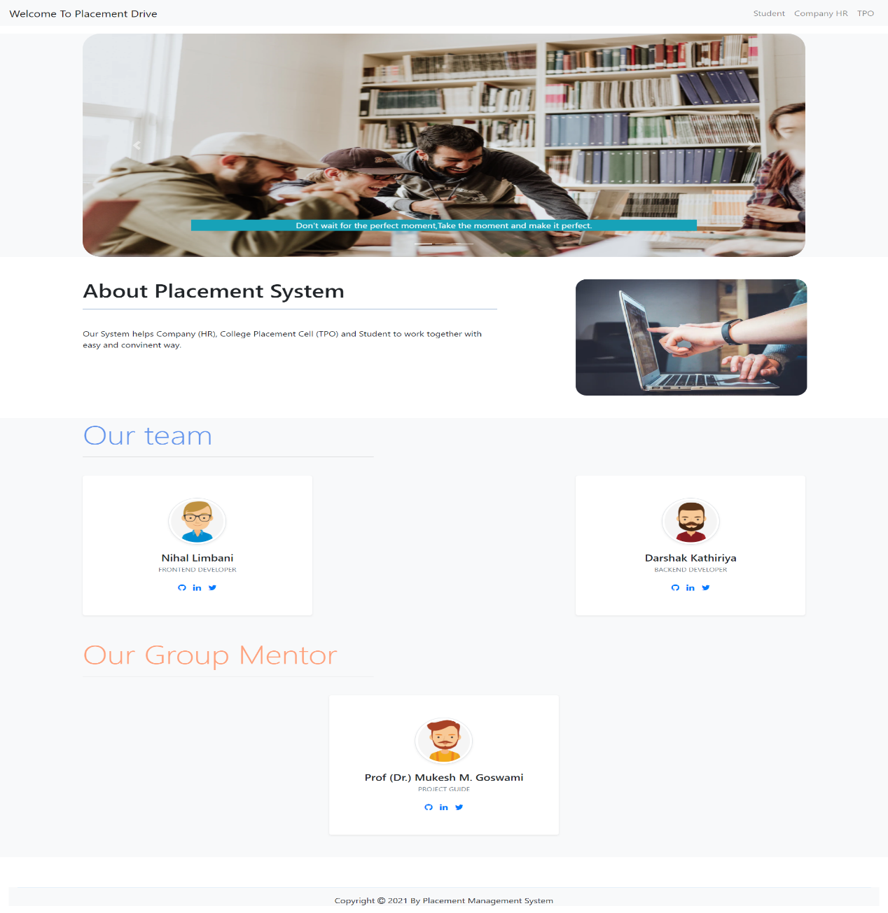

-Login page of TPO

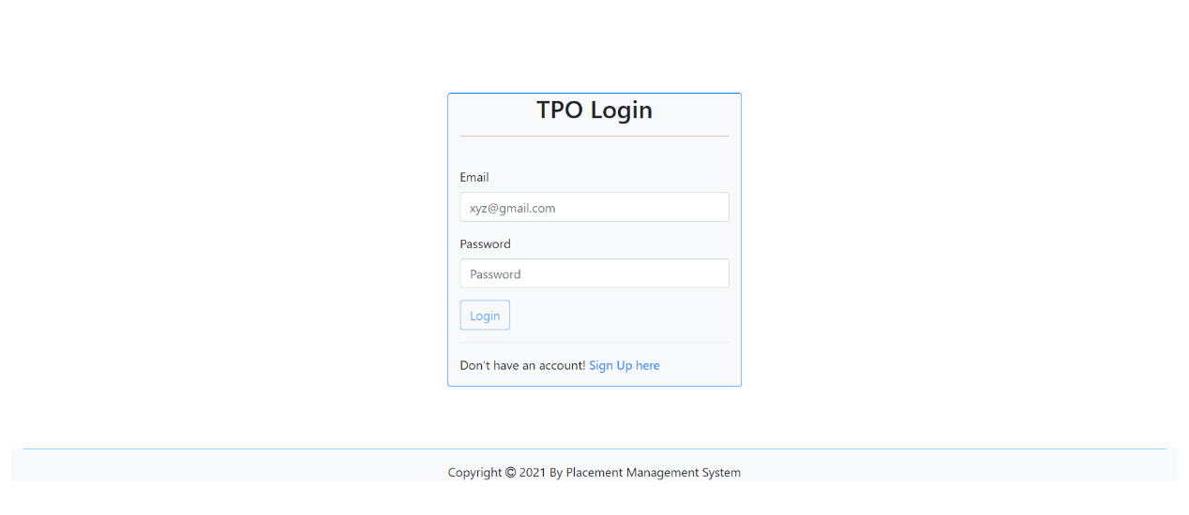

there is also seen same login page for Company (HR) and Student.

-SignUp Page of TPO

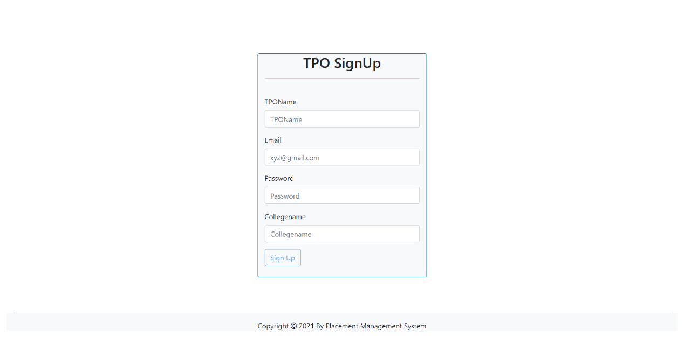

there is also seen as same SignUp page with some different input for Company(HR) and Student.

-TPO home Page

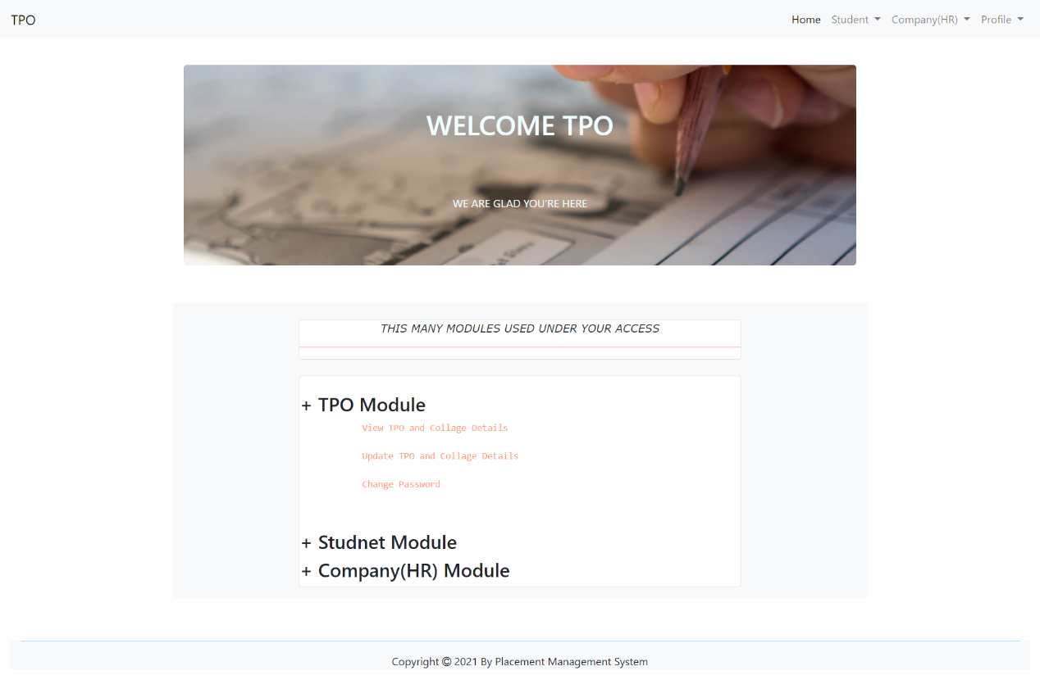

-TPO View Profile

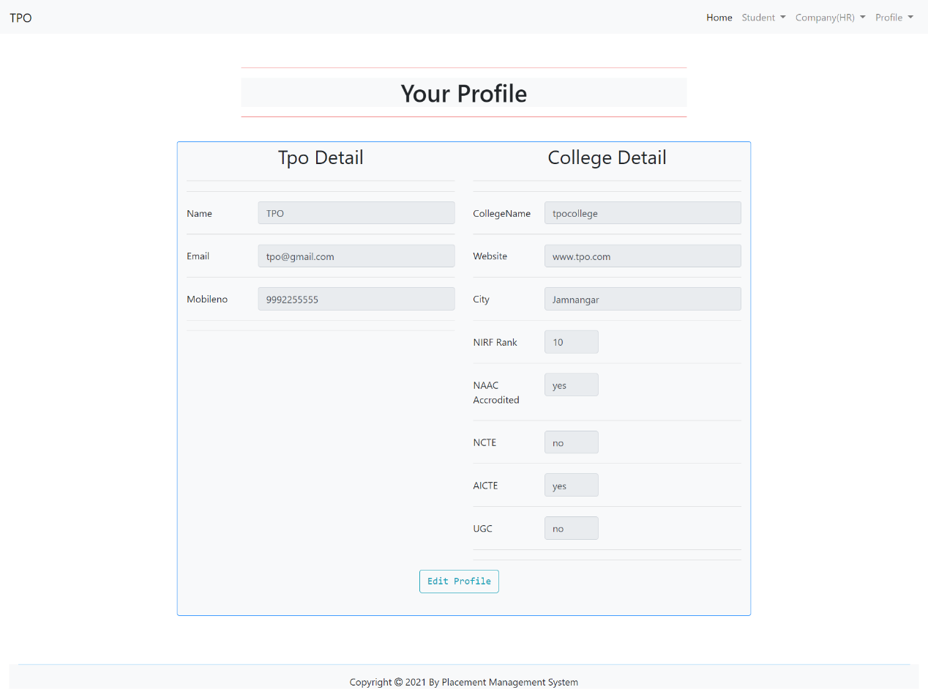

There is also seen same page with different field for Company (HR) and Student.

-TPO Edit Profile

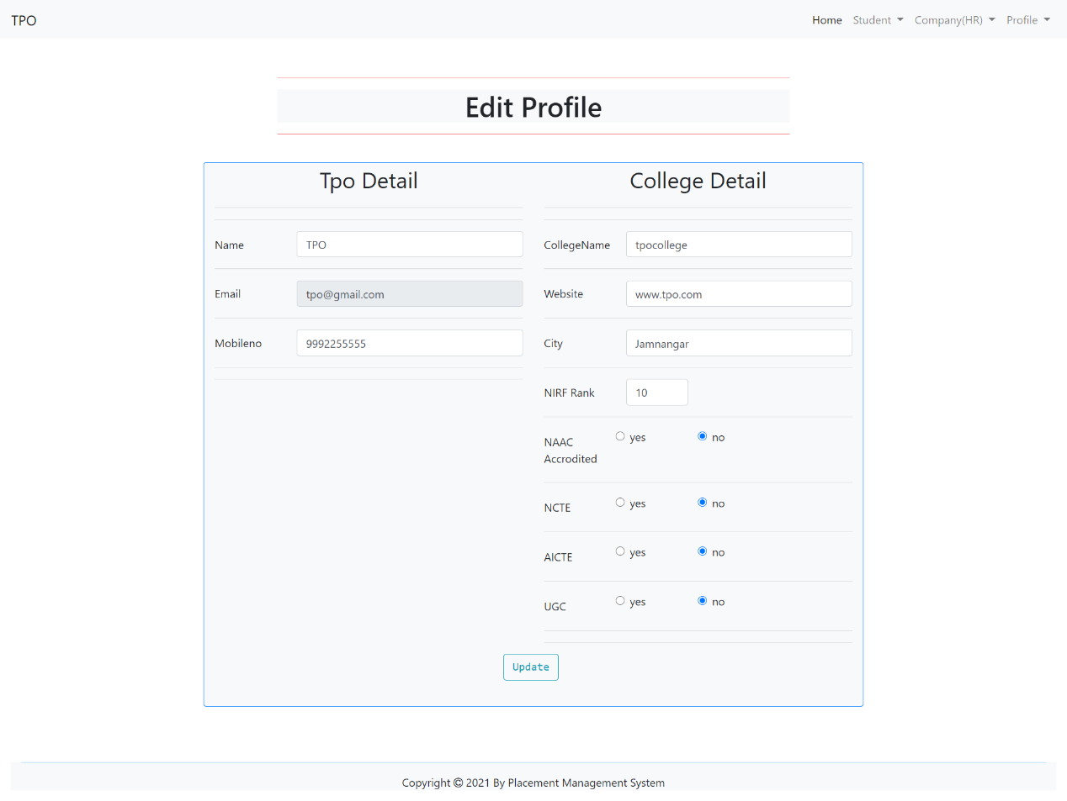

There is also seen same page with different field for Company (HR) and Student.

-TPO Change Password

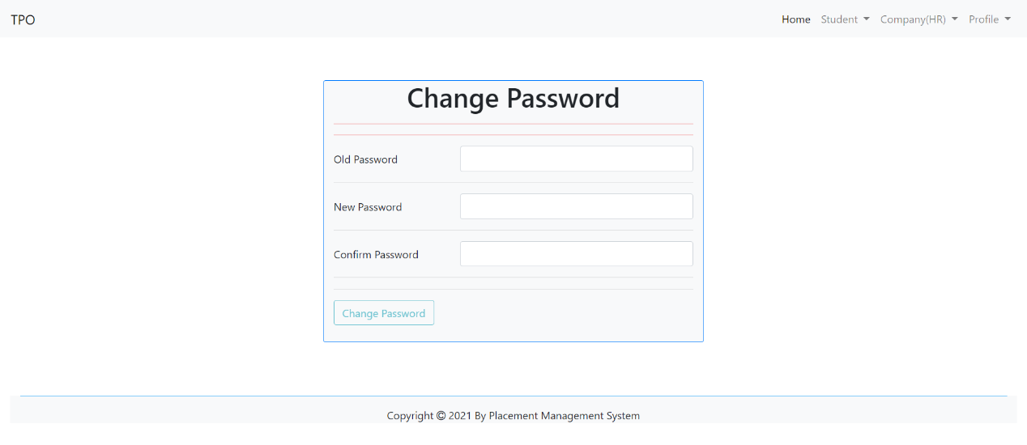

There is also seen same page with same functionality for Company (HR) and Student.

-Add Student (As TPO User)

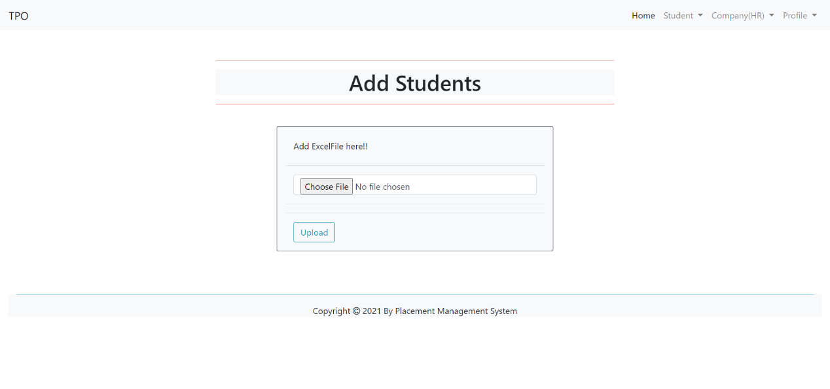

-TPO Job Request

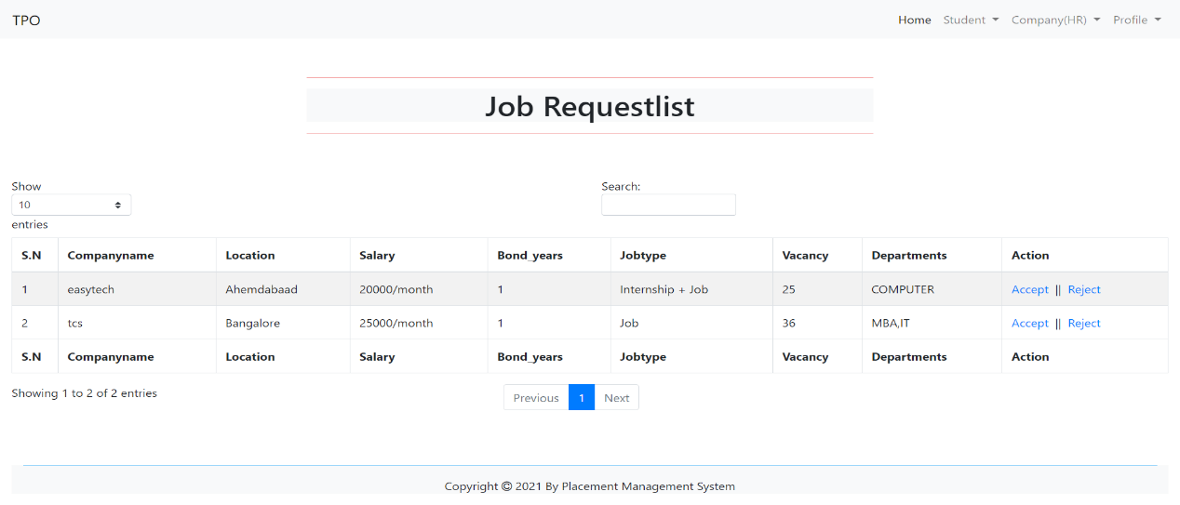

User can accept or reject request.

-Job Announce to Student(User TPO)

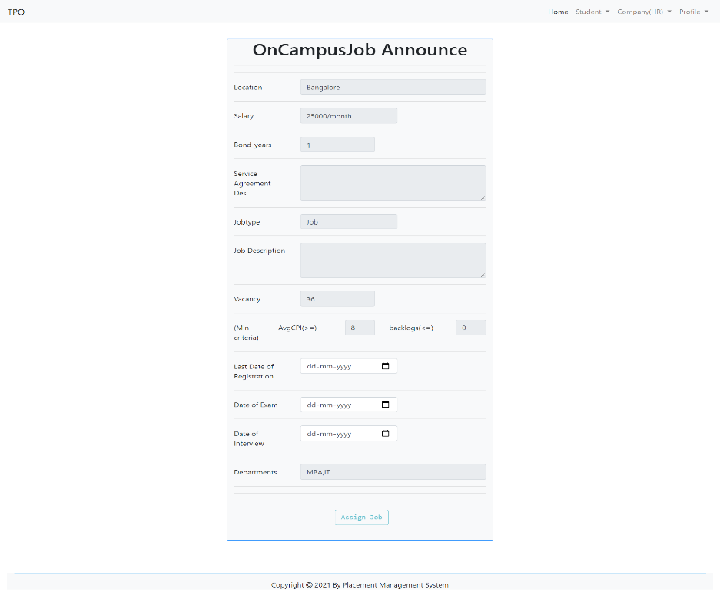

-TPO Announced OnCampusJob List

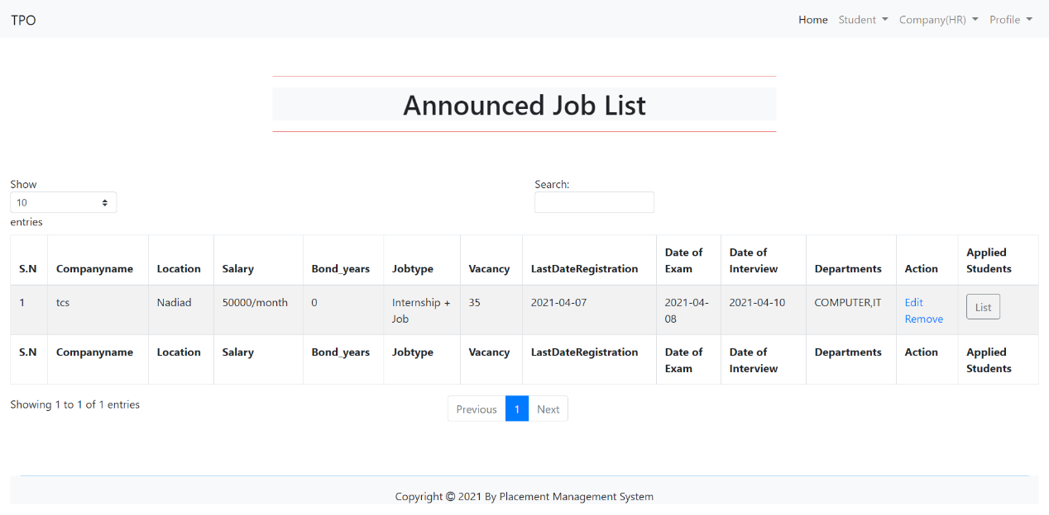

User can edit dates and also remove job from their student.

-TPO Applied Student List For particular Job

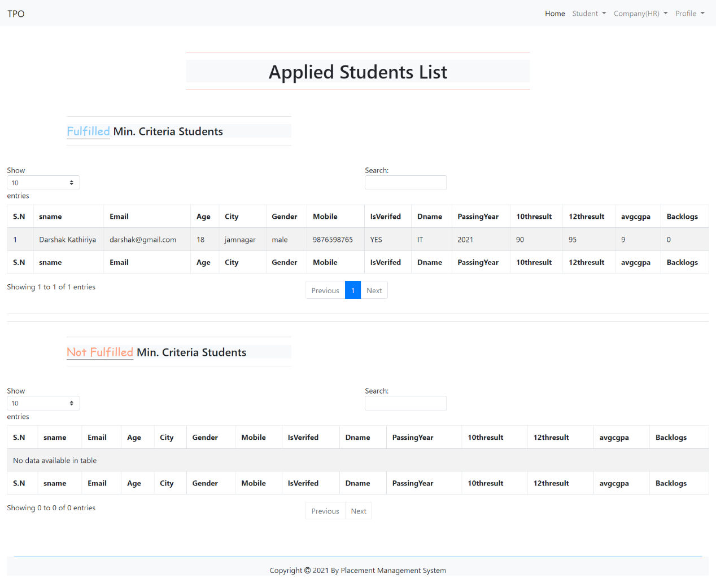

- As TPO User it also can see all company details and student details with search functionality.

-Company(HR) Offcampus Job Announce

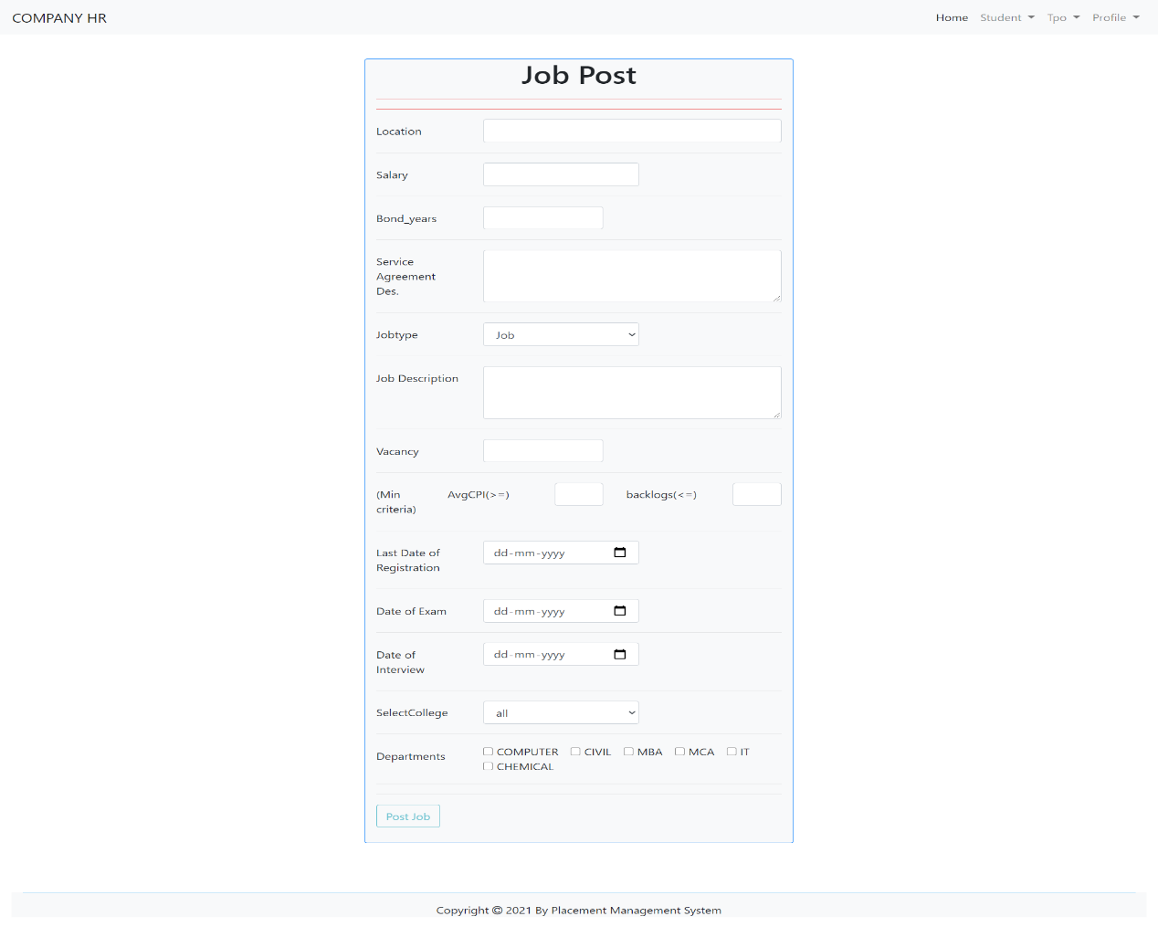

-Company (HR) View Annouced Offcampus Job

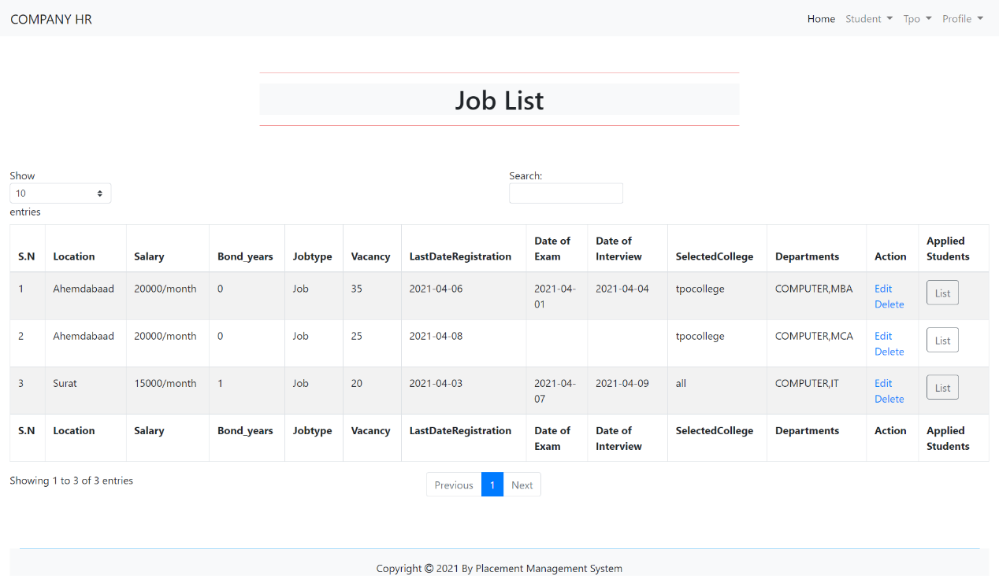

User can edit or delete any of Job.

- Company (HR) see Offcampus applied student for particular job

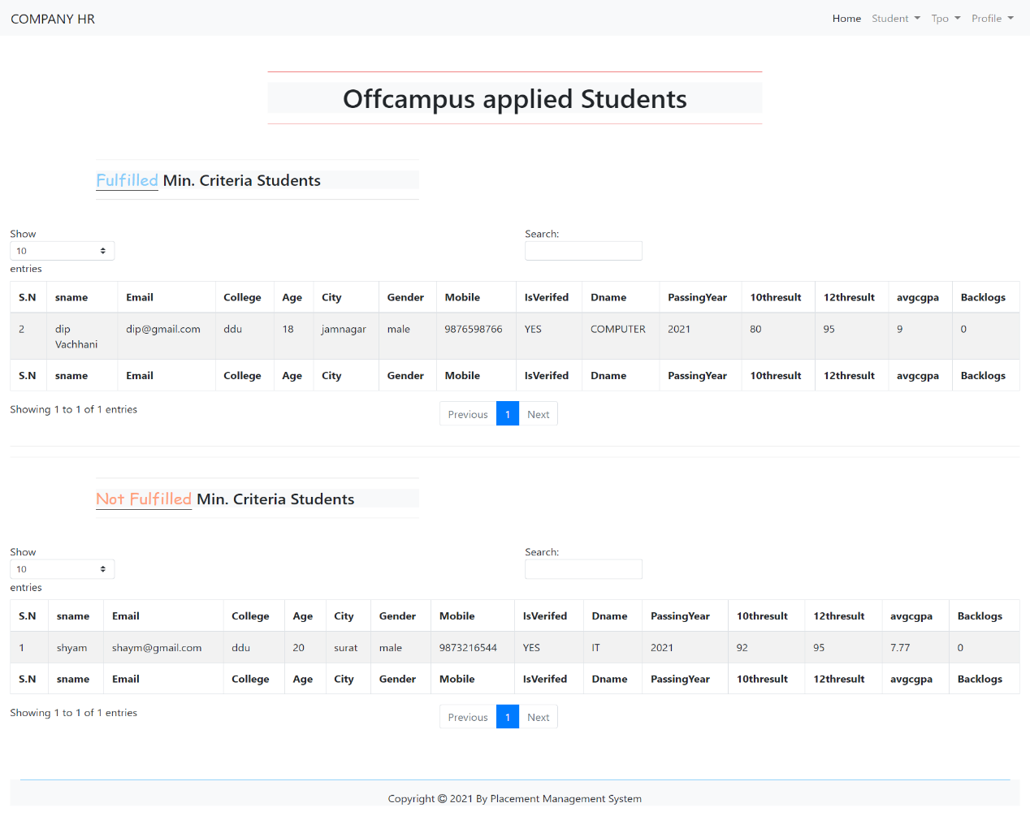

User see applied student list based on criteria and also search student if required.

-Company (HR) Request TPO

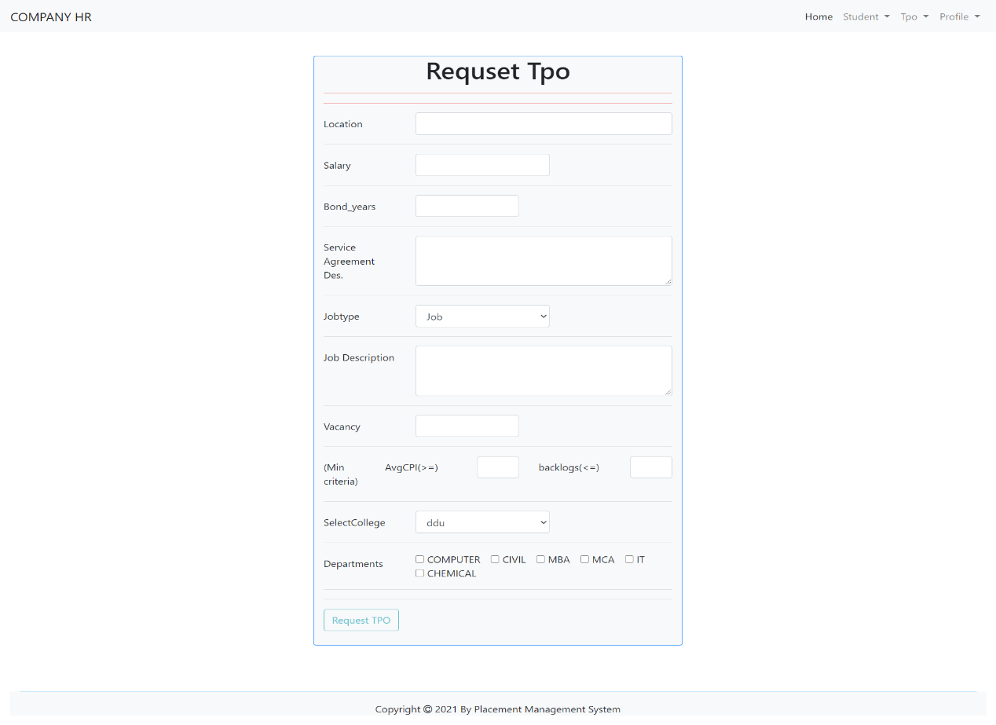

-As Company (HR) User can see List of job request.

-Company (HR) Can See accepted Job request And Announced Job.

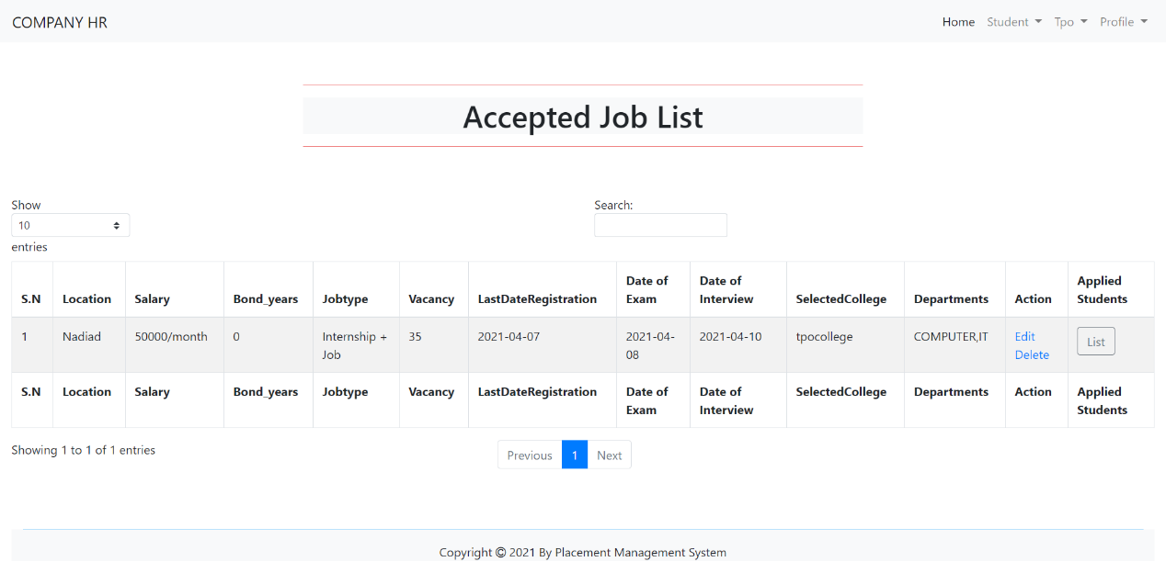

- As Company (HR) User can edit and delete assigned job and also see Oncampus applied student List.

-As Company (HR) User can see List of rejected job and also delete that request.

-Student Can See Offcampus Job announce

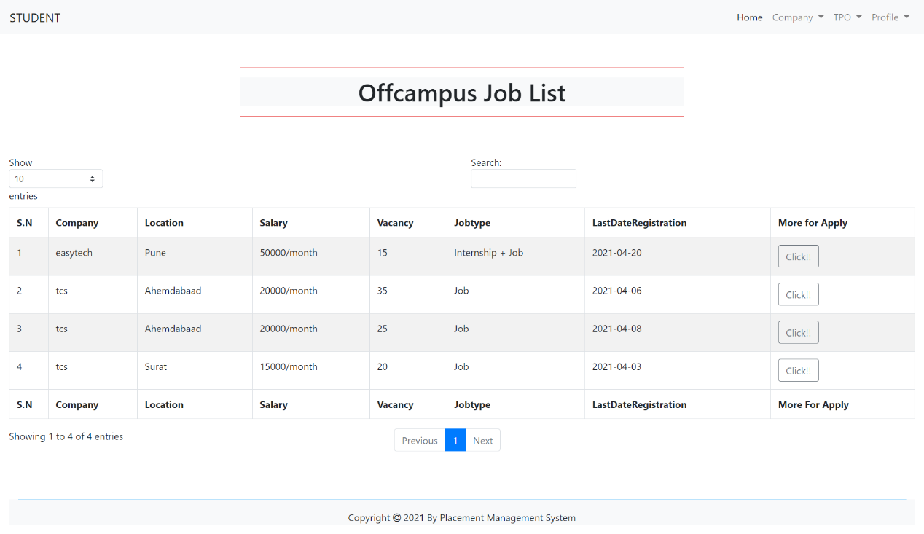

Also likely Same page with valid Oncampus Job list there.

-Student Can Apply Offcampus Job

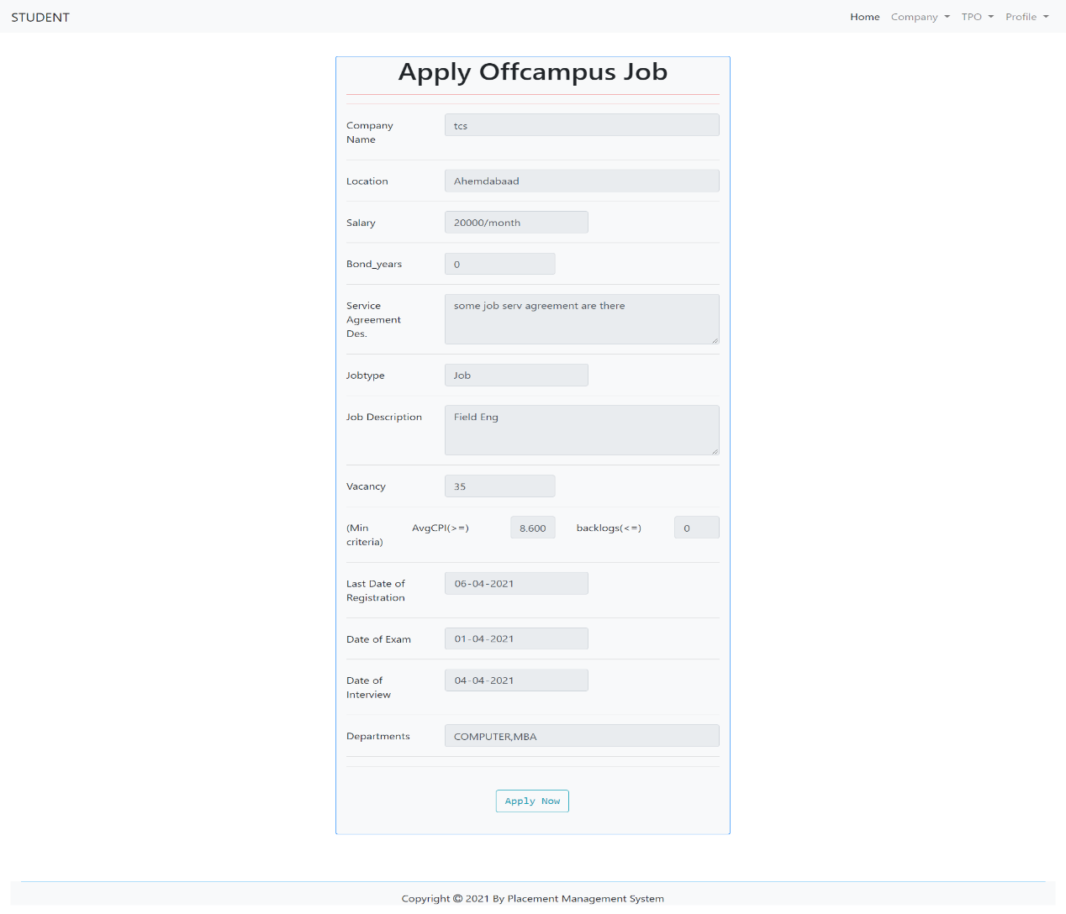

Also likely Same page with valid Oncampus Job apply there.

Student Offcampus Applied Job List

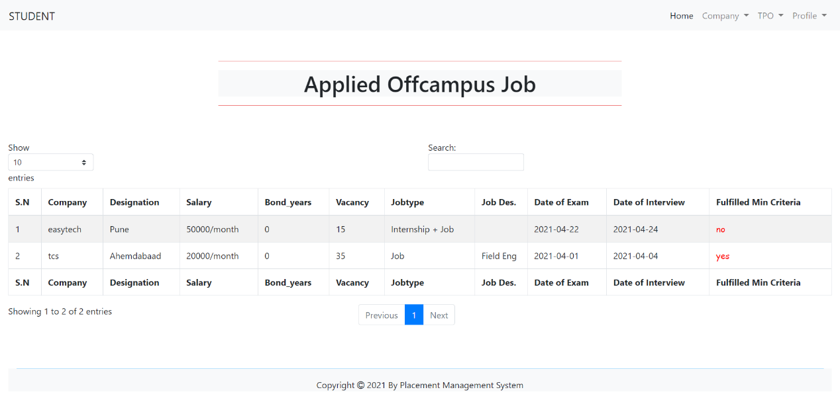

Also likely Same page with valid Oncampus Job appled job there.

1. **LIMITATION AND FUTURE ENHANCEMENT**
   1. **Limitation**

* No authentication for User Registration.
* No Facility to Company (HR) to announce selected students list to our system.
* No Facility to New Job Announce Email Notification.
  1. **Future Enhancement**
* Better UI will be prepared.
* Some of the current new flaws if found we would be resolving them as soon as possible.
* We will try to implement more functionality for TPO, Company (HR) as well as Students. Ex. In Company (Hr) will update selected students List on our system, TPO and Student will see that details.
* We will try some of our system function to more advance.

1. **CONCLUSION AND DISCUSSION**
   1. **Conclusion**

According to us, this project gave all of us the confidence to believe in ourselves and a great experience of how to work as a team. It also boosted our technical coding as well as time management skills.

To complete this project, first We understood the need of such system then We gathered relevant data and Started work on it. After that We started designing and coding phase for actual implantation of the system.

* 1. **Discussion**
     1. **Self-Analysis of Project Viabilities**

According to us, this project is absolutely a good start for gaining hands-on experience on projects. It is useful if it is managed according to the goal for which it is made.

**10.2.2 Problems Encountered and Possible Solutions**

There are so many problems encountered during this project.

1. Problem to maintain databases.
2. Need to change some functionality fully which lead to do the whole work again.
3. Some Problem Solve easily with some of changes.
   * 1. **Summary of Project Work**

It is a great achievement to successfully complete the project. The prior knowledge of software engineering has helped immensely in overcoming the various road blocks. We have done work with pre-planned scheduling related with time constraints and weekly progress in project development.

1. **REFERENCES**

* Npm Packages: <https://www.npmjs.com/>
* Node Js/Express Js MDN: <https://developer.mozilla.org/en-US/docs/Learn/Server-side/Express_Nodejs>
* Stackoverflow: <https://stackoverflow.com>
* Node Js: <https://nodejs.dev/learn>
* Geeksforgeeks: <https://www.geeksforgeeks.org/>
* Youtube: <https://www.youtube.com/>
* jQuery: <https://learn.jquery.com/>
* Bootstrap 4: https://getbootstrap.com/docs/4.6/getting-started/introduction/
* W3 Schools: <https://www.w3schools.com/>
* Mysql Document: <https://docs.oracle.com/en-us/iaas/mysql-database/>